SESSION 10: RDBMS (CONTD.)

Assignment 2

**5. Problem Statement**

4. Return the first name, last name and city of all customers who live in Canada. Order the results first by the last then by the first name.

Solution:

Qurery that will be used.

**SELECT customer.first_name,customer.last_name,city.city,country.country**

**FROM customer JOIN address ON customer.address_id = address.address_id**

**JOIN city ON address.city_id = city.city_id JOIN country ON city.country_id = country.country_id WHERE country.country='Canada' ORDER BY customer.last_name,customer.first_name**

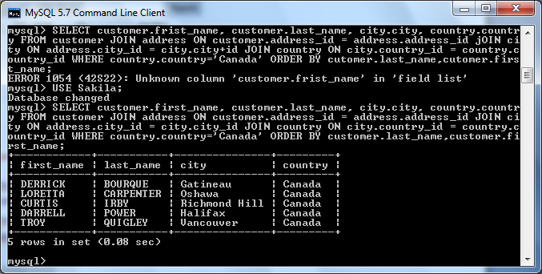

In result we will get 5 rows with customer first name, second name, city under country Canada.

5. How many customers are from Brazil?

Solution:

Query used to obtain the result is:

**SELECT country.country, COUNT(customer.customer_id) AS total_customers**

**FROM customer JOIN address ON customer.address_id = address.address_id**

**JOIN city ON address.city_id = city.city_id JOIN country ON city.country_id = country.country_id**

**WHERE country.country='Brazil';**

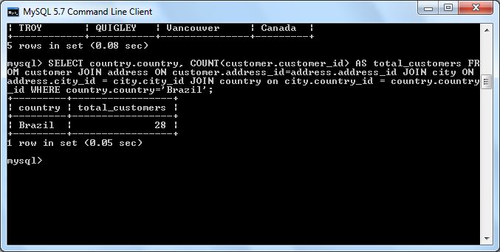

From result we got to know that we have total of 28 customers in country ‘Brazil’.

6. Return the "popular countries"? (that is, the ones with more than 20 customer). For each such country, return its name and it’s correspond number of customers. Order the result by the number of customers (descending).

Solution:

Query we use to obtain the result.

**SELECT country.country, COUNT(customer.customer_id) AS total_customers**

**FROM customer JOIN address ON customer.address_id = address.address_id**

**JOIN city ON address.city_id = city.city_id JOIN country ON city.country_id = country.country_id**

**GROUP BY country.country HAVING COUNT(customer.customer_id)>20**

**ORDER BY total_customers DESC,country.country;**

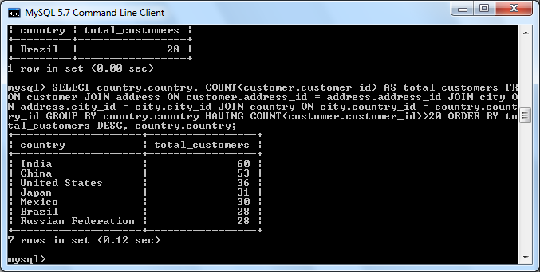

**As a result we get 7 popular countries. Topping the chart is India with 60 customers.**